Microsoft Entra Connect Setup

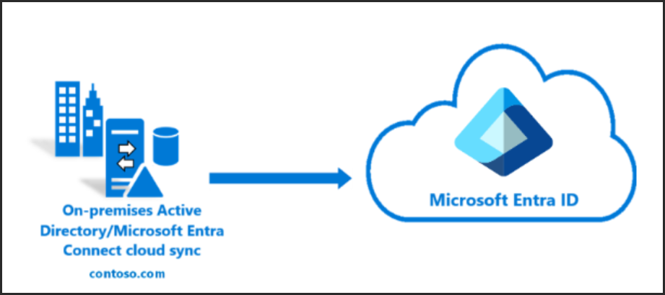

Prerequisites Checklist

make sure you’ve got:

• ✅ Windows Server 2025 VM joined to your on-prem AD domain

• ✅ On-prem Active Directory already configured (AD DS role installed)

• ✅ Azure AD tenant ready (with Global Admin access)

• ✅ Internet access from the VM

• ✅ Optional but recommended: a dedicated service account for Azure AD Connect

**Step-by-Step:**

Download Entra Connect – Cloud Sync

Get the latest version from your Entra Portal:  
[https://entra.microsoft.com](https://entra.microsoft.com/#view/Microsoft_AAD_Connect_Provisioning/AADConnectMenuBlade/~/GetStarted)  
  
Click Entra Connect > Get Started > Manage > Download Connect Sync Agent

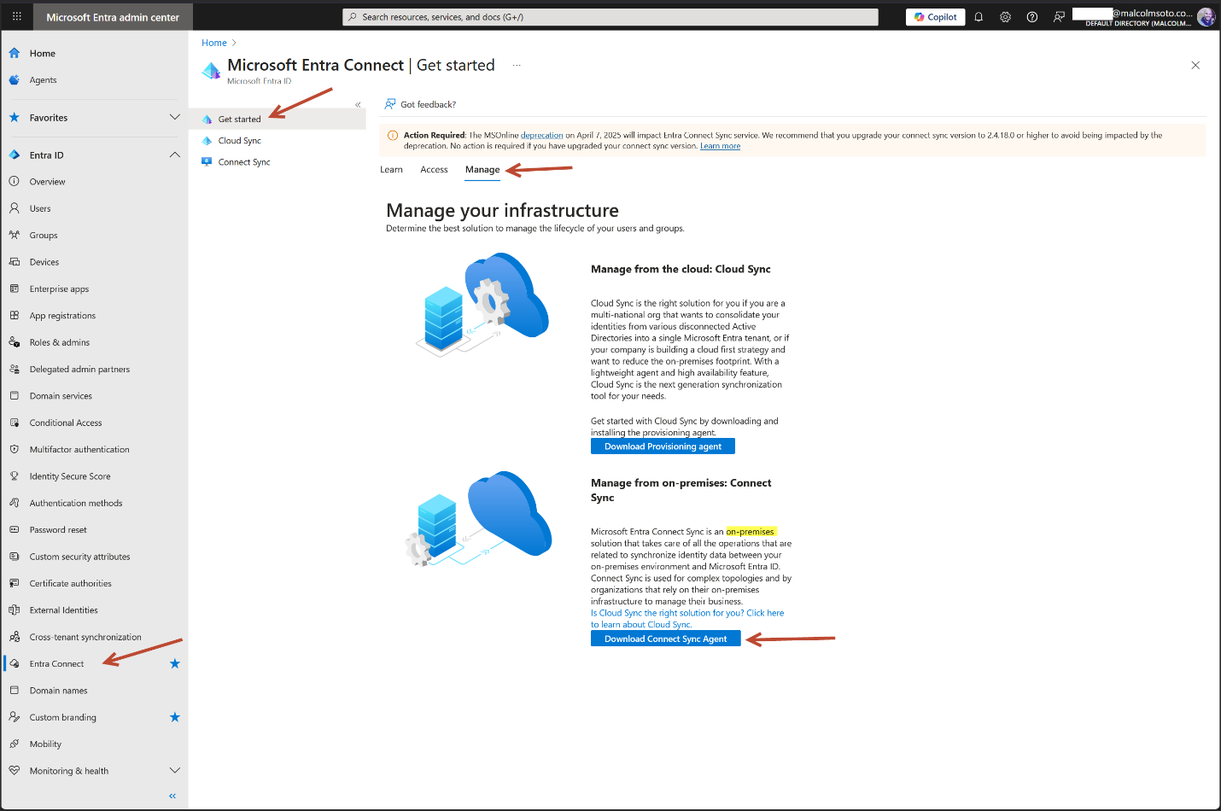

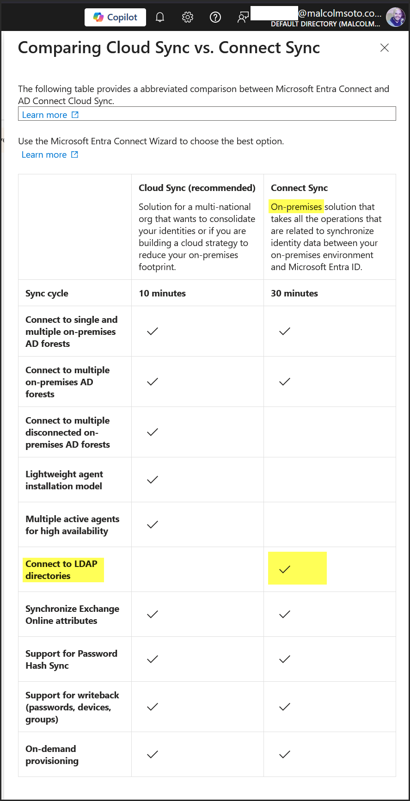

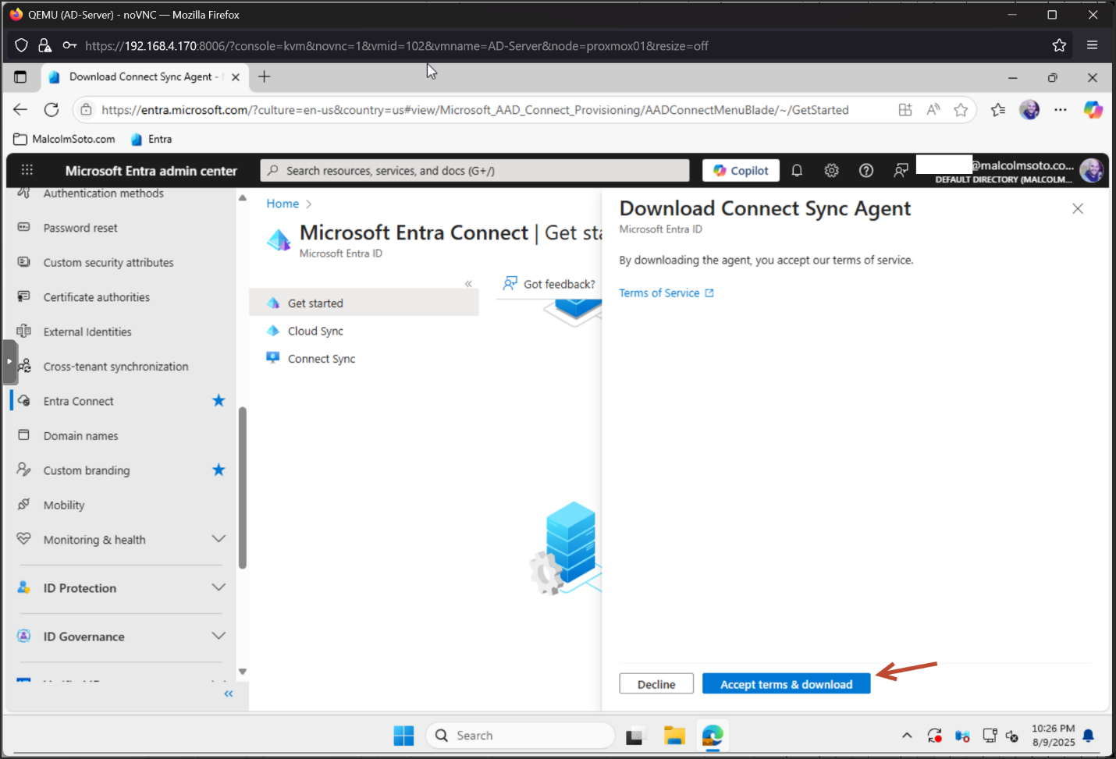

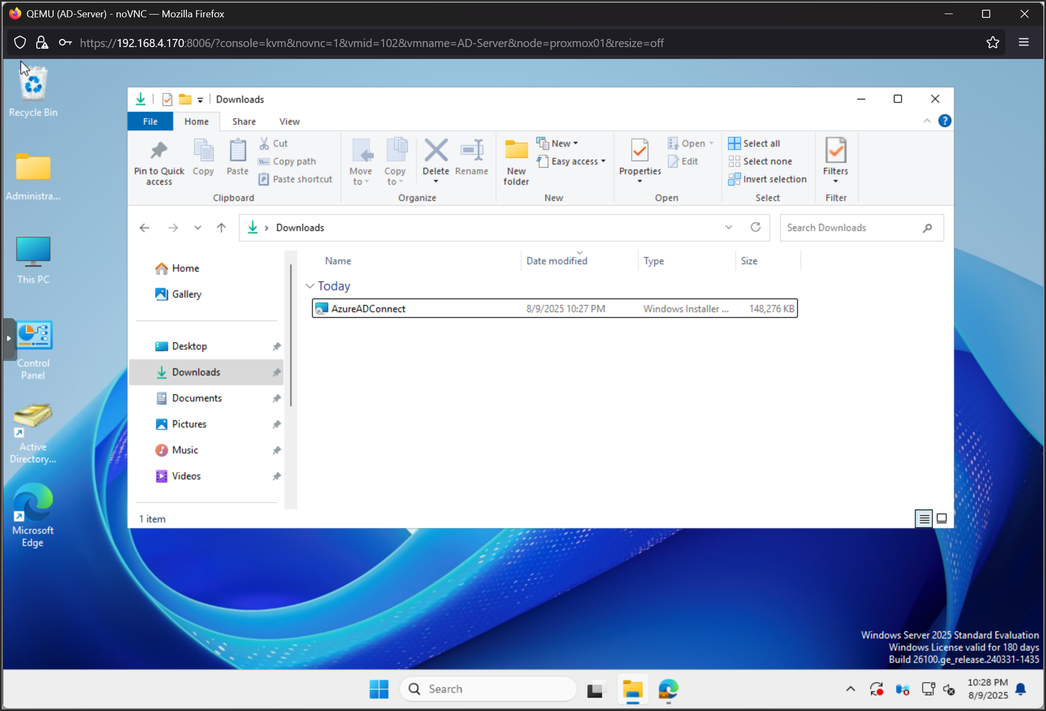

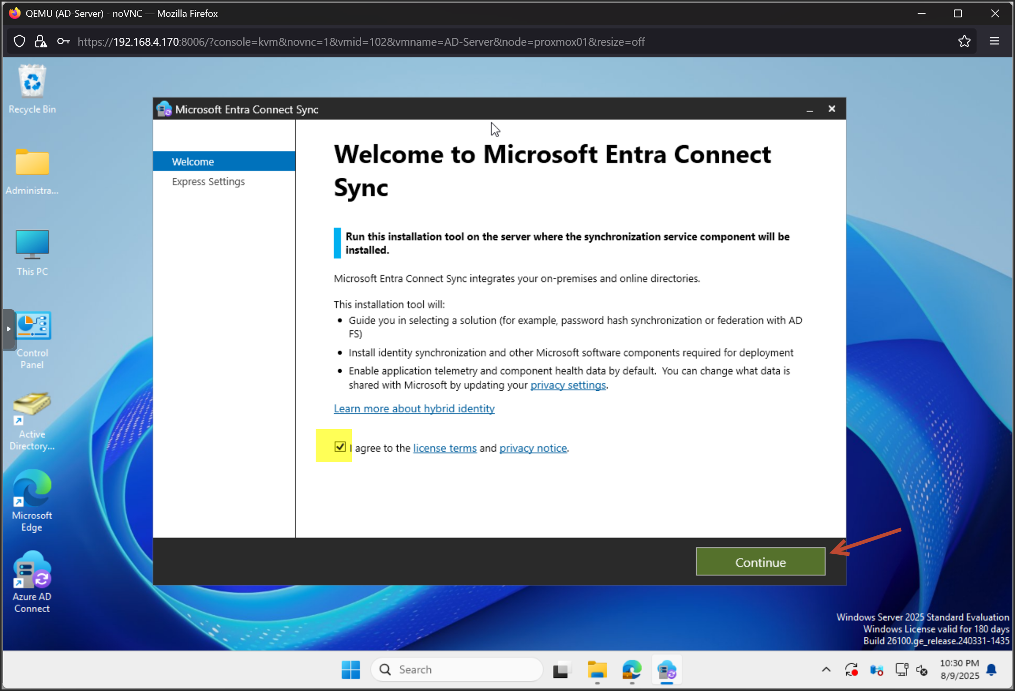

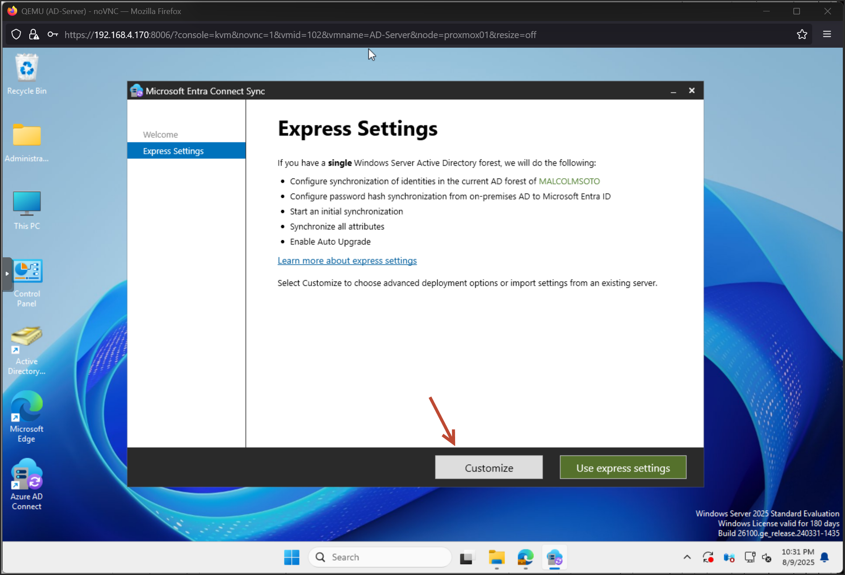

Make a service account – password don’t expire

Add the new account in the “Log on as a service” in **secpol.msc**

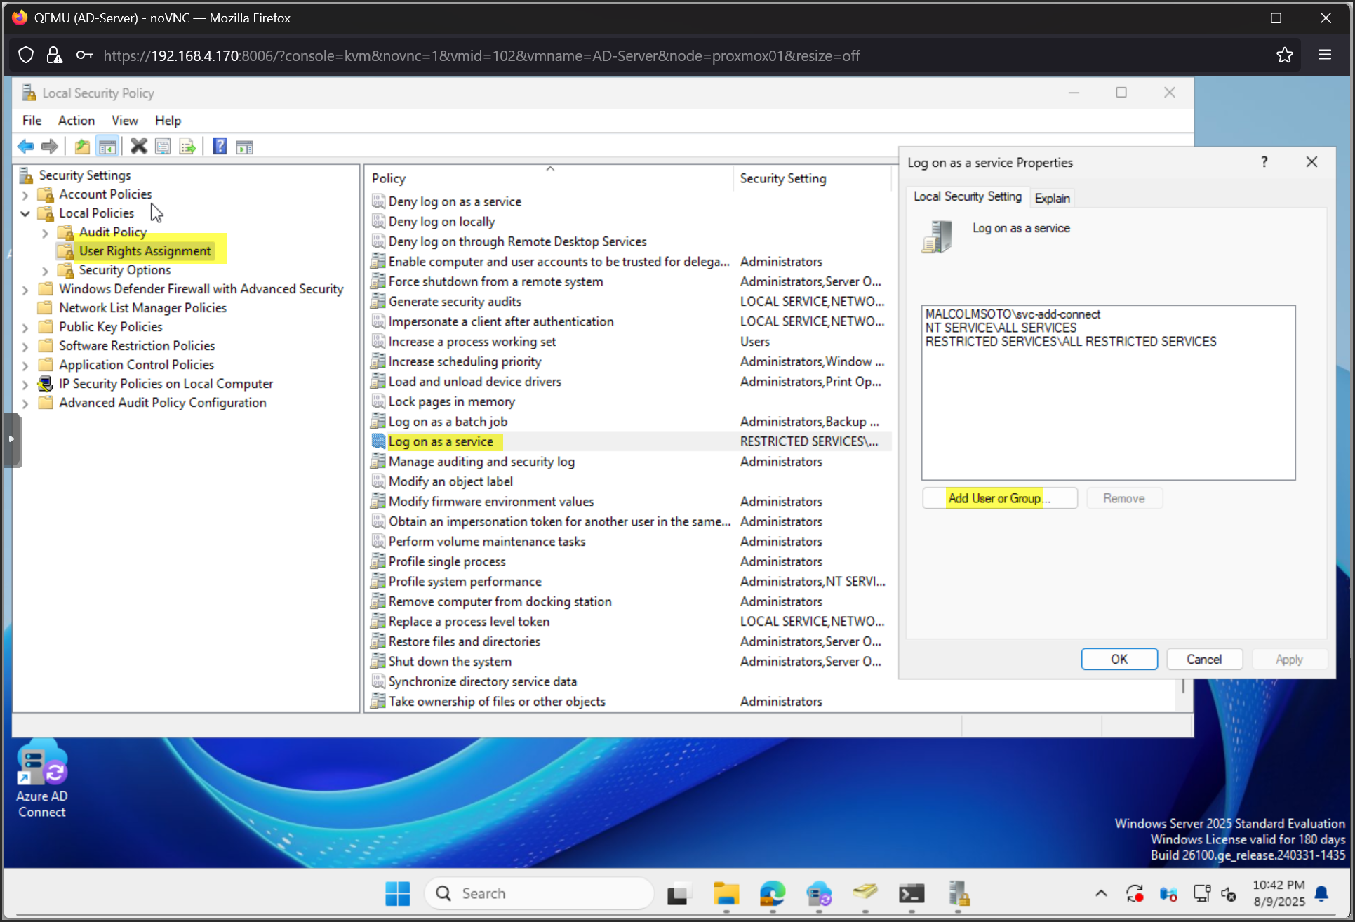

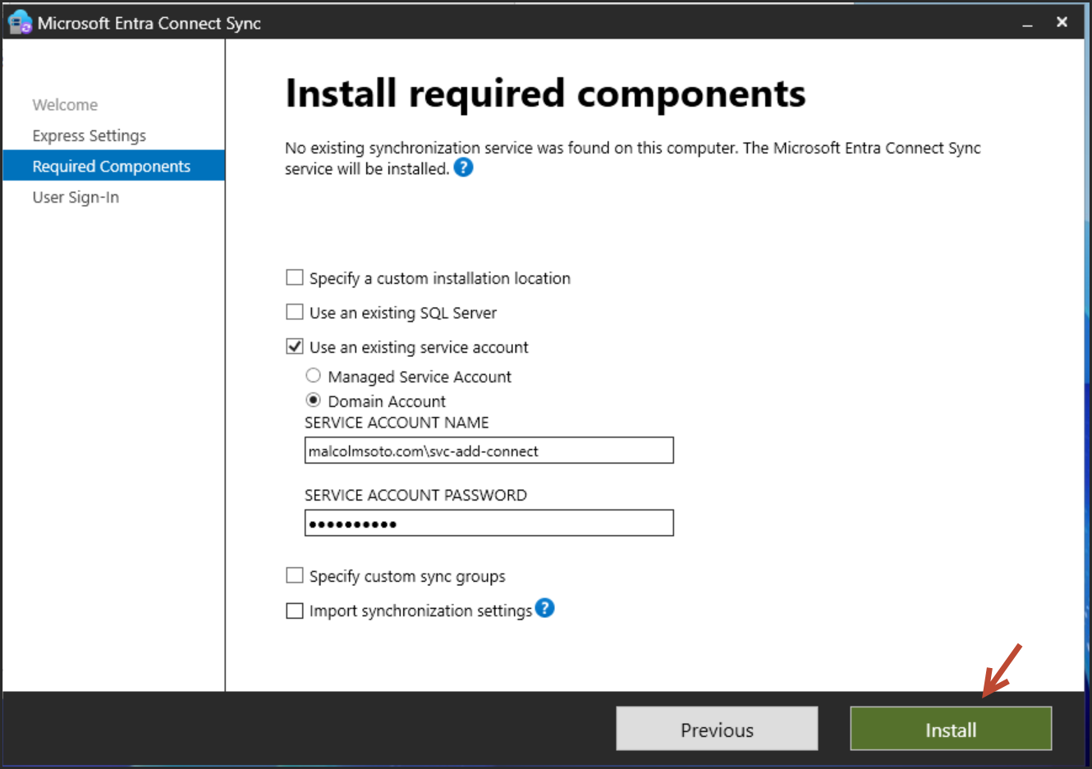

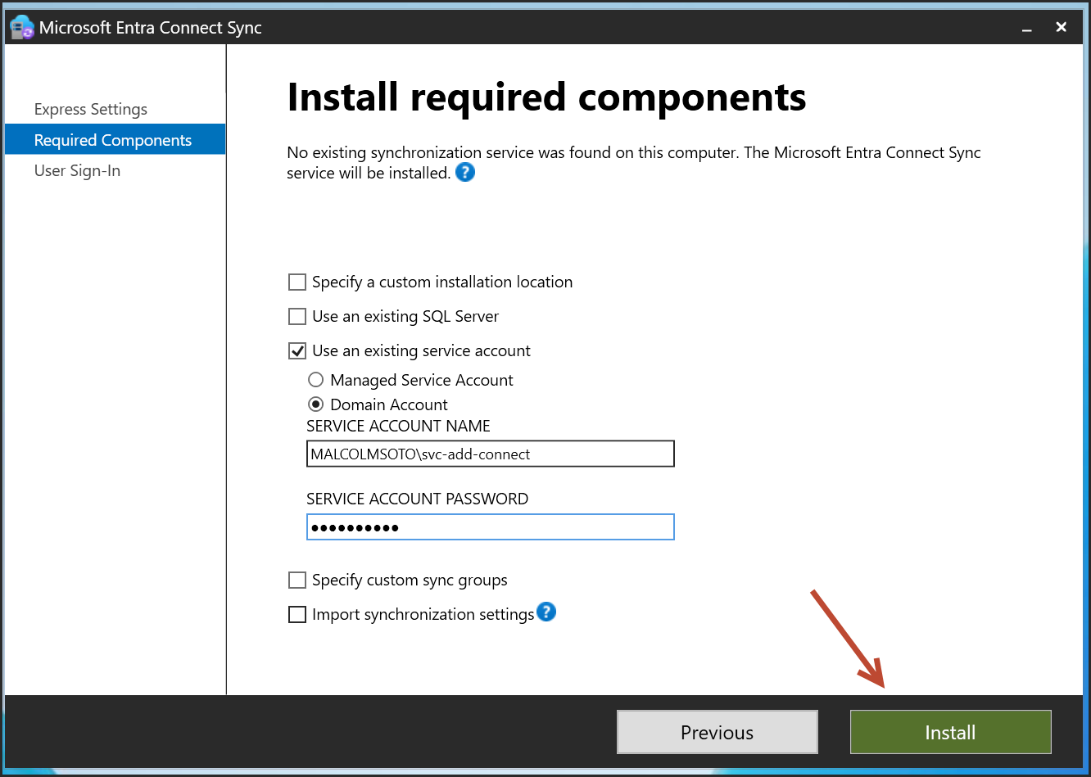

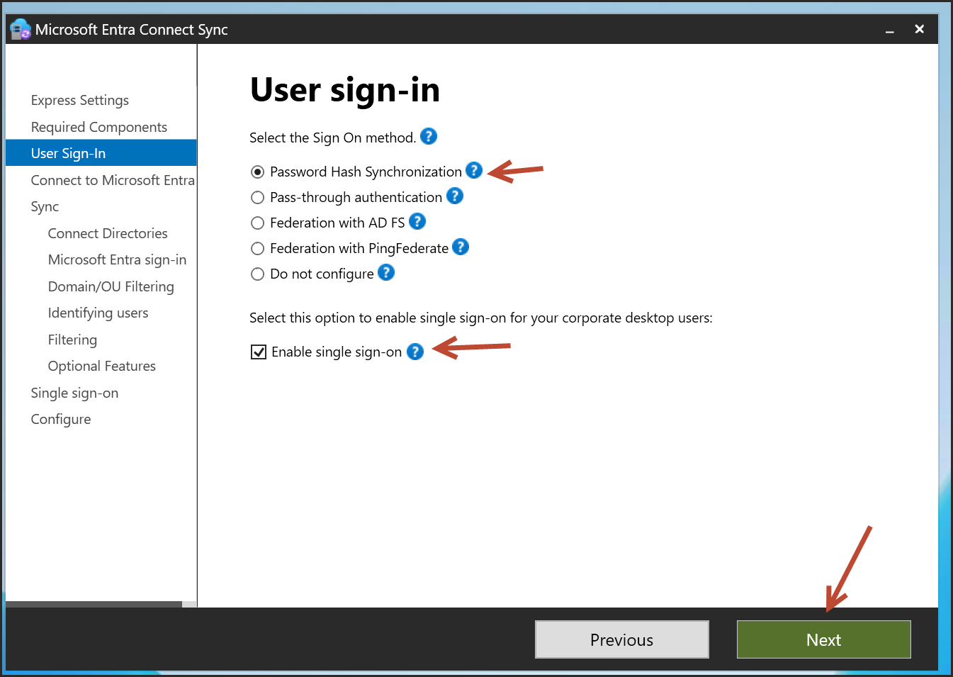

✅Recommended Selection

• Password Hash Synchronization

This is the simplest and most reliable method for hybrid identity in a lab or small enterprise setup. It syncs password hashes from your on-prem AD to Azure AD, allowing users to sign in with the same credentials.

• Optional: Enable Single Sign-On (SSO)

You can check this box if you want seamless sign-in for domain-joined devices. It requires a small change to your on-prem AD (adds a computer account and configures Kerberos SSO). Since you're testing Conditional Access and Autopilot, enabling SSO will give you a smoother experience.

🛑 When to Use Other Options

• Pass-through authentication:

Only if you need real-time password validation against your on-prem AD. More complex and less resilient than hash sync.

• Federation with AD FS / PingFederate:

Enterprise-grade setups with external identity providers. Not needed for your lab.

• Do not configure:

Only if you're planning to set up sign-in manually later.

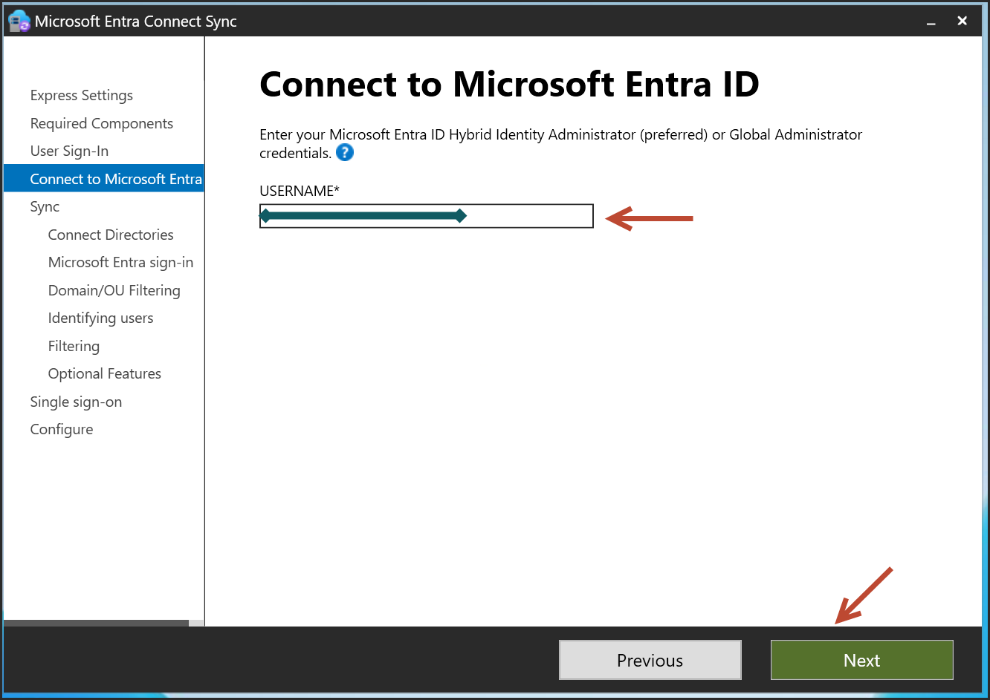

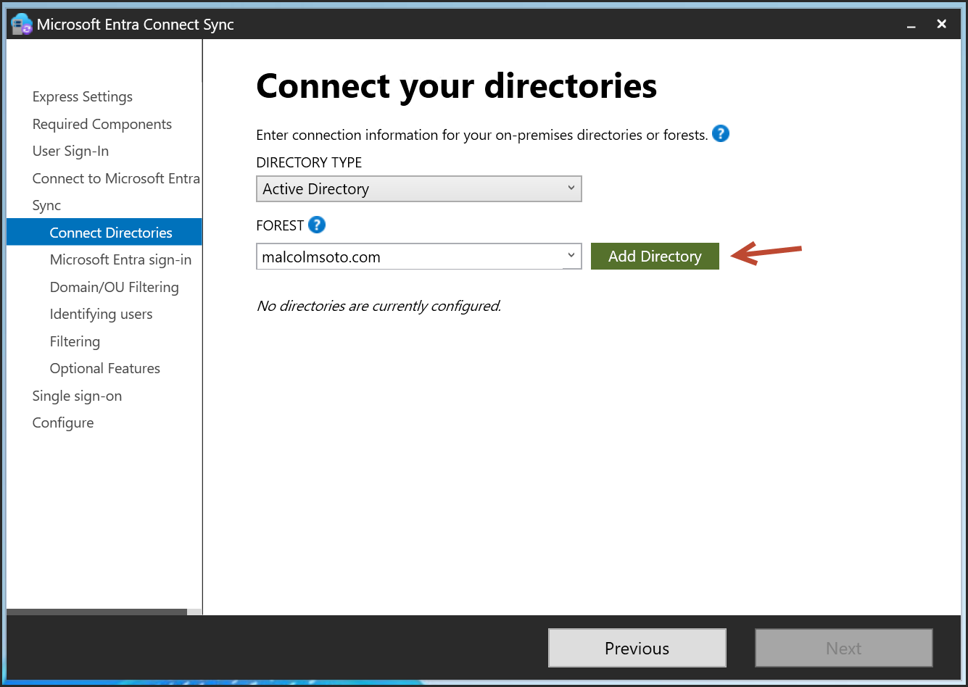

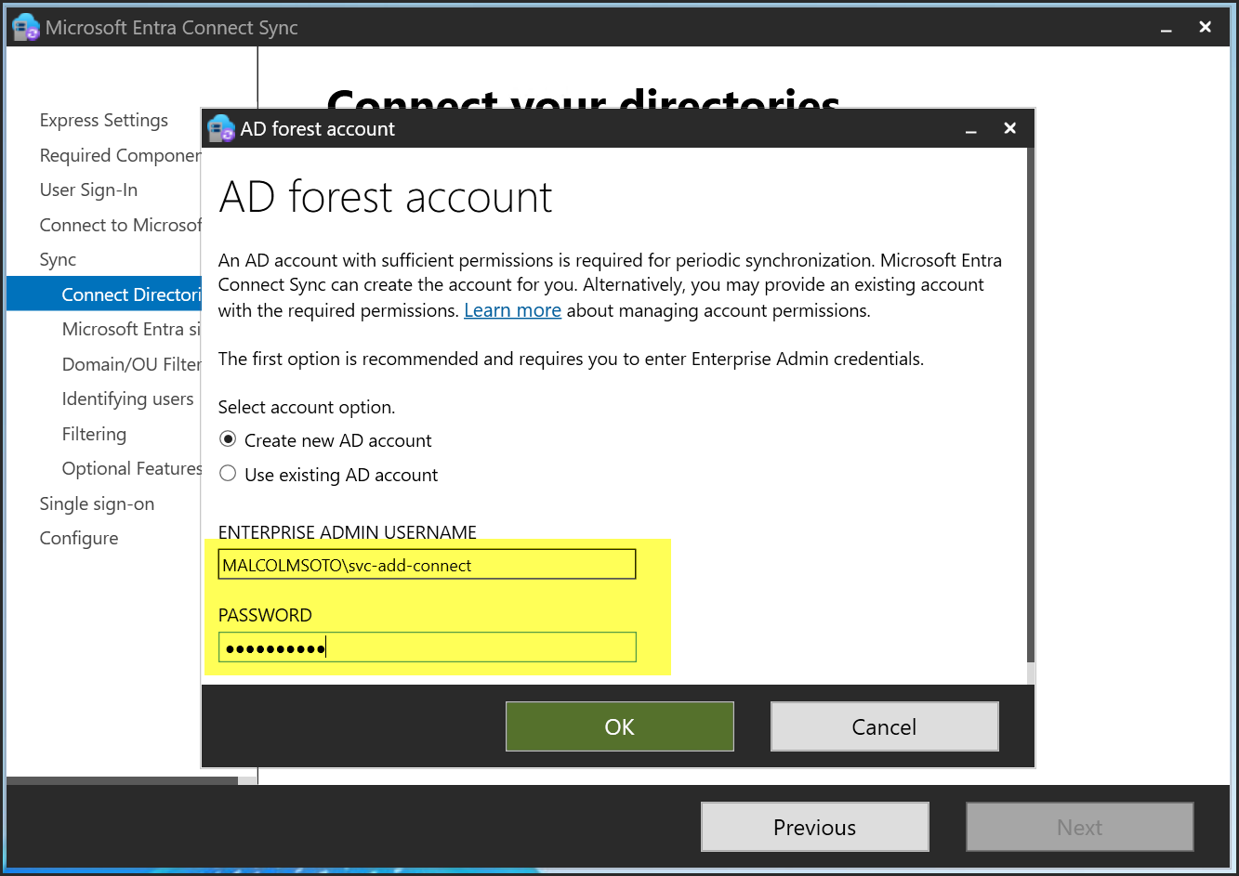

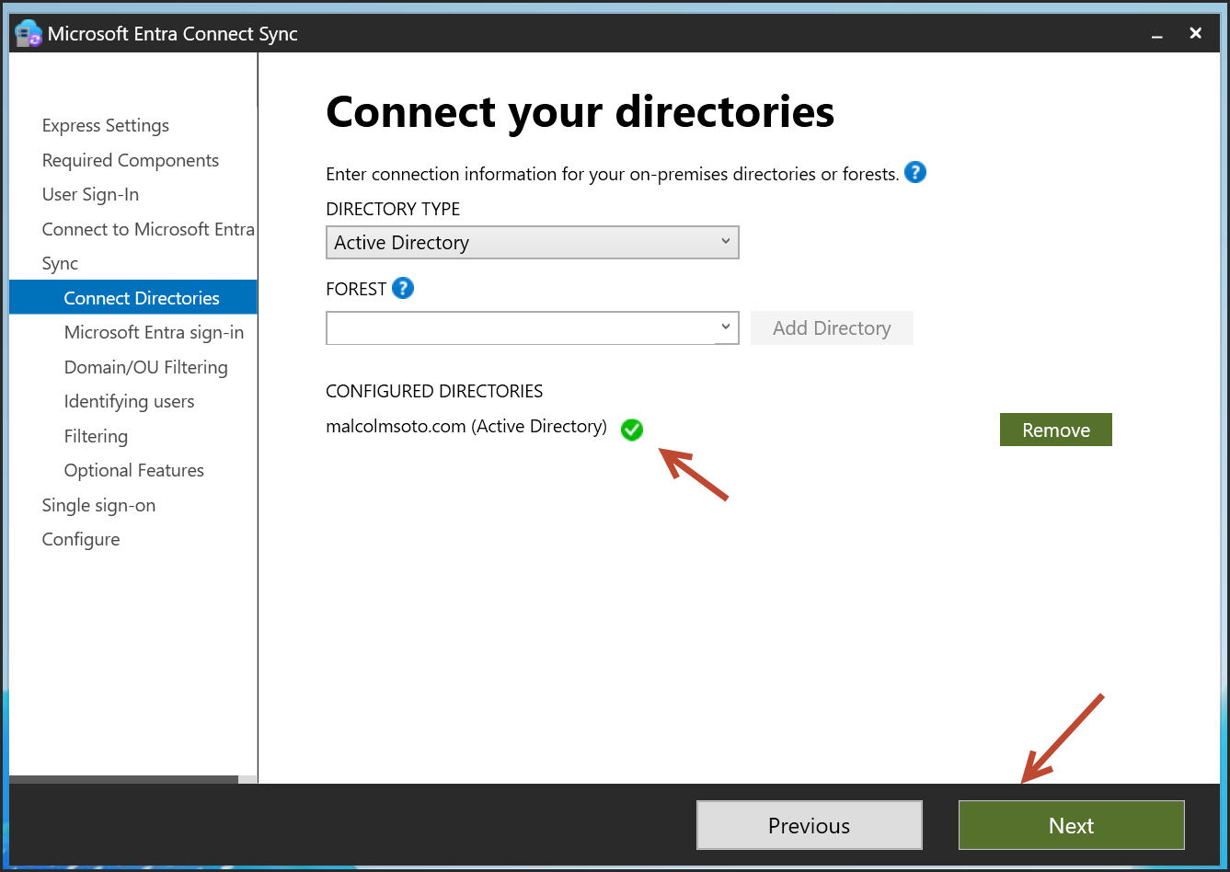

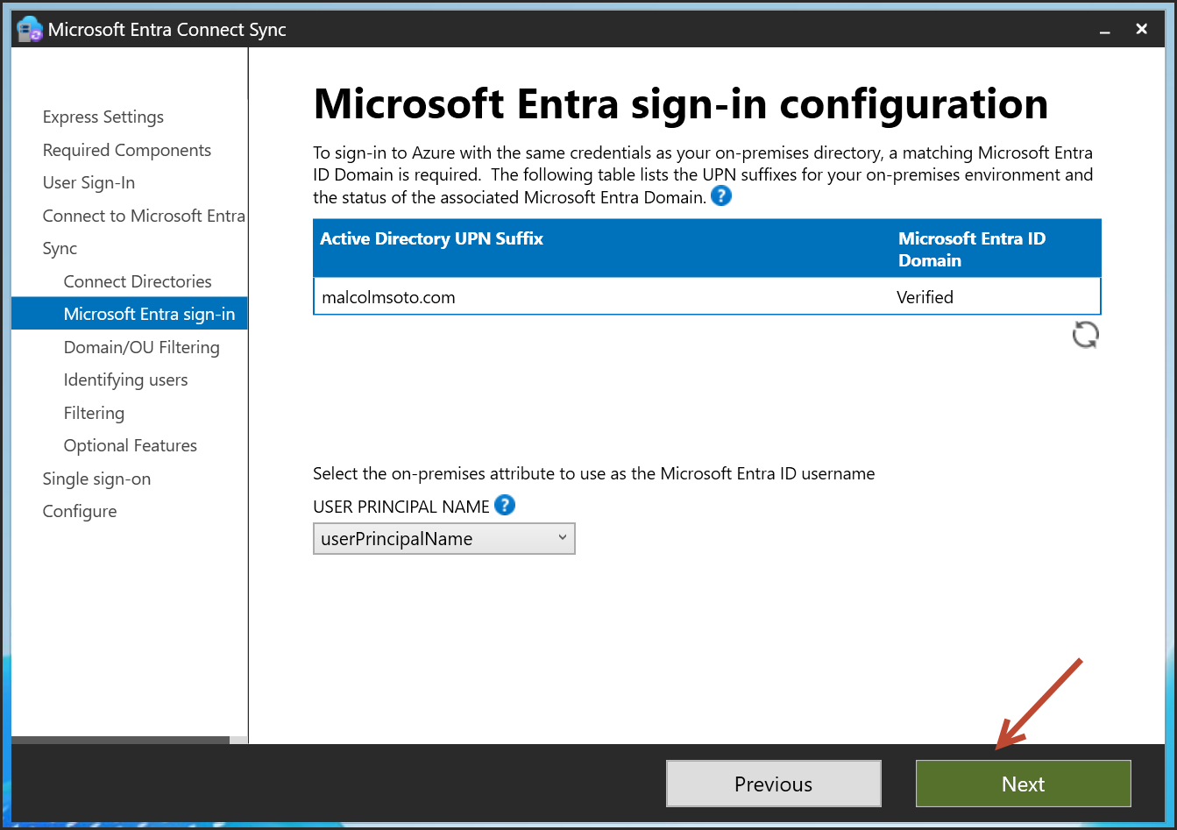

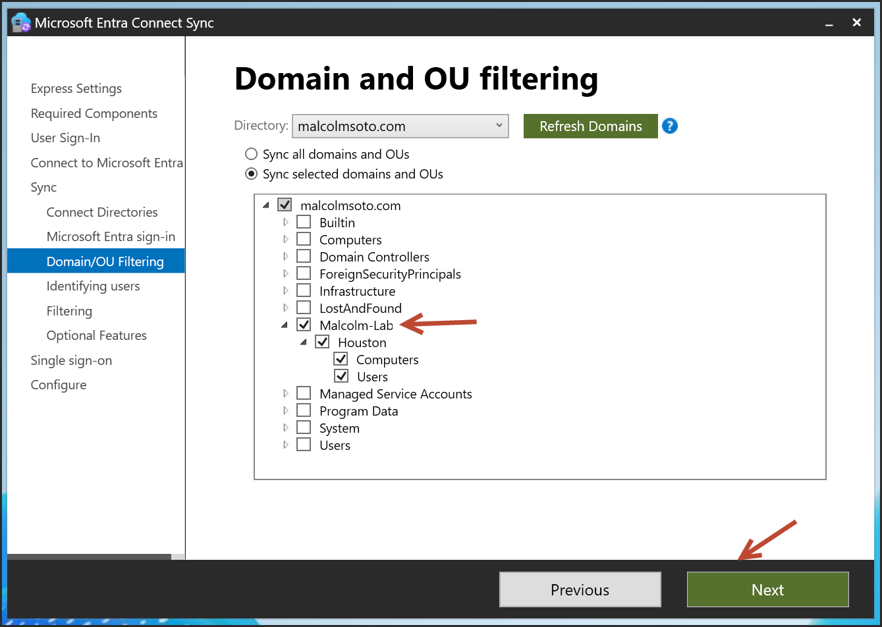

I created a OU to only sync what I want

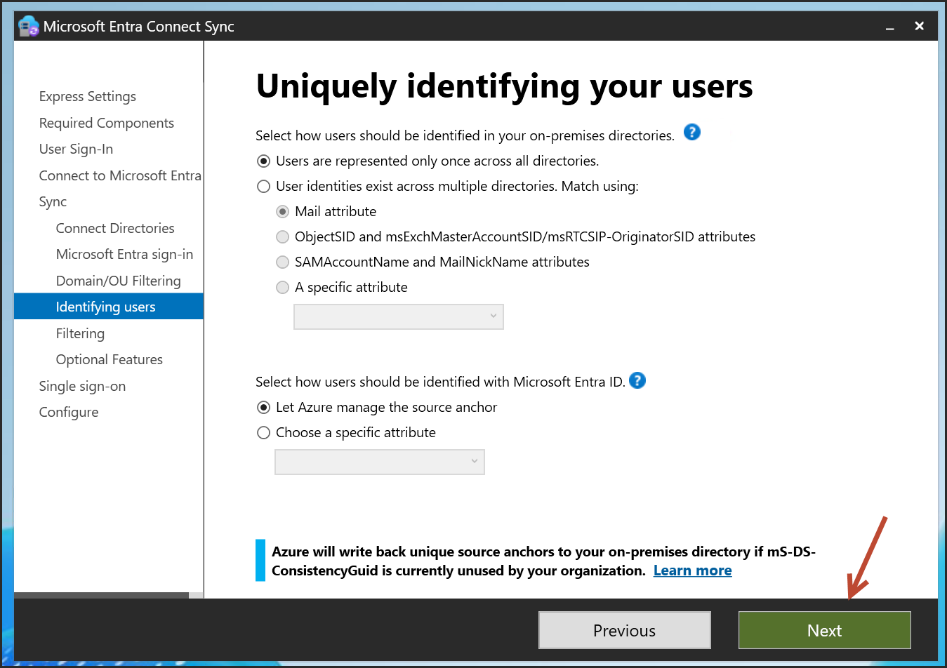

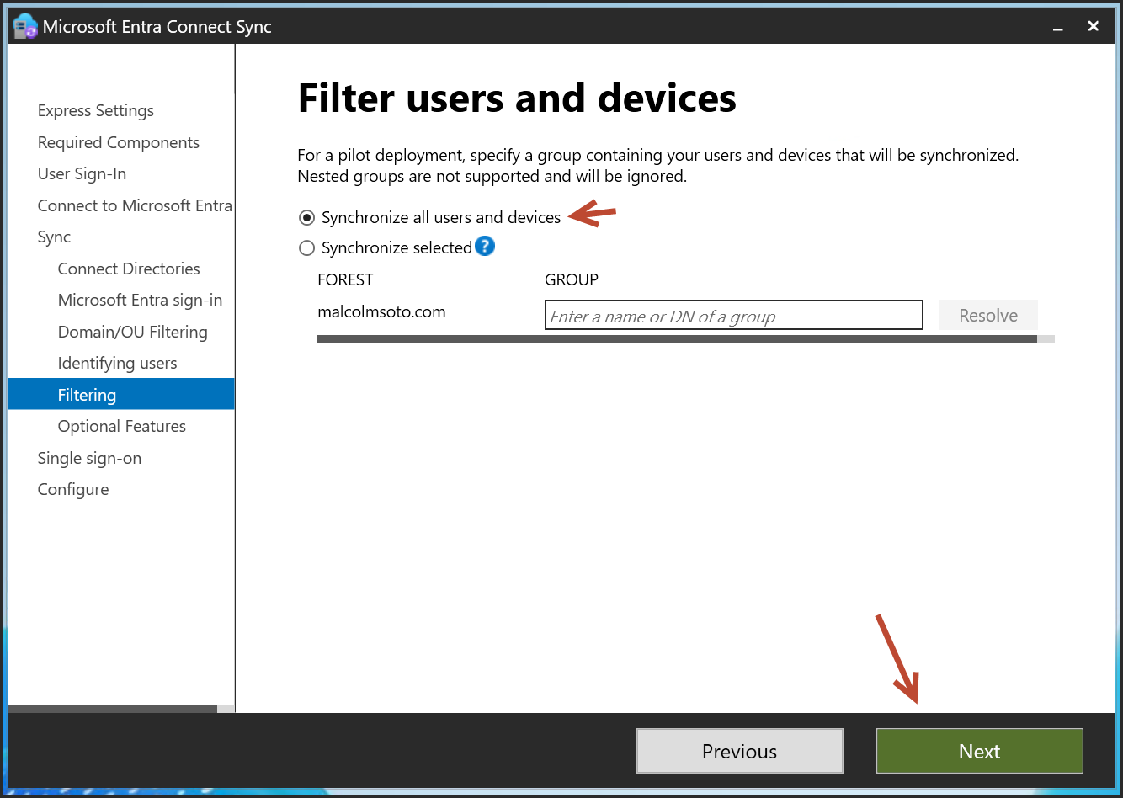

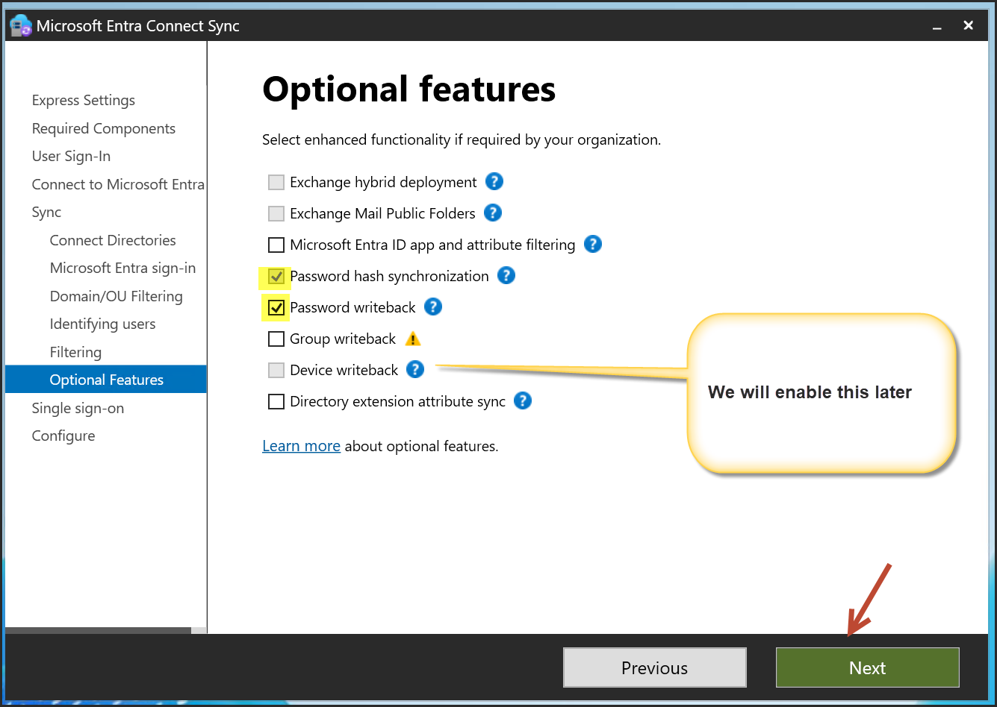

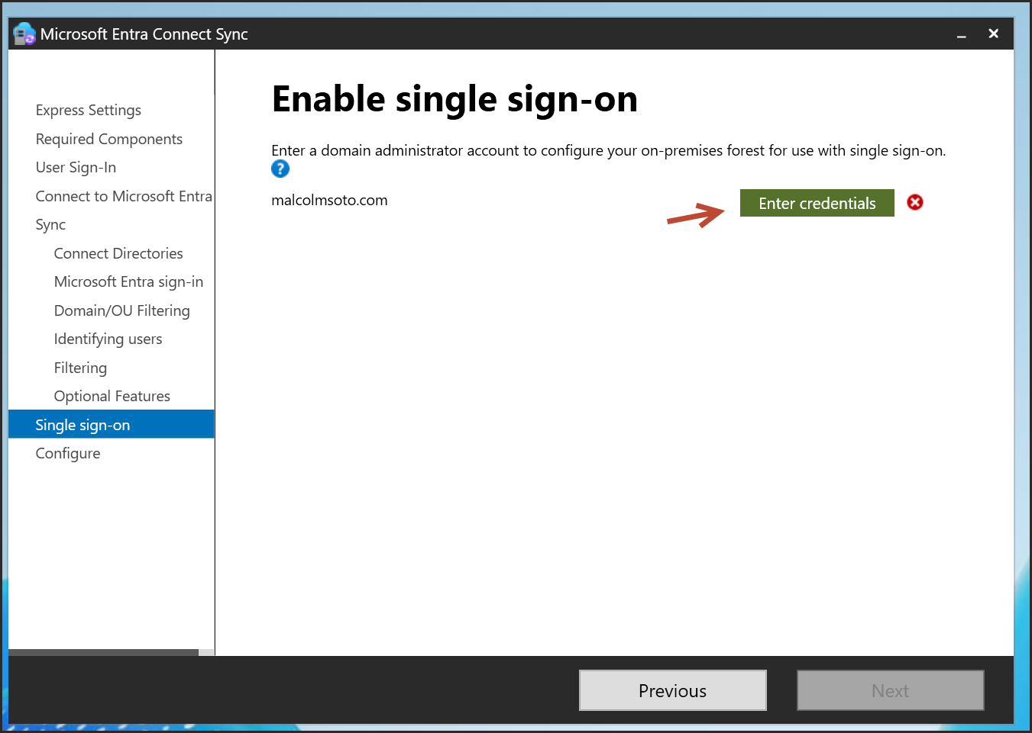

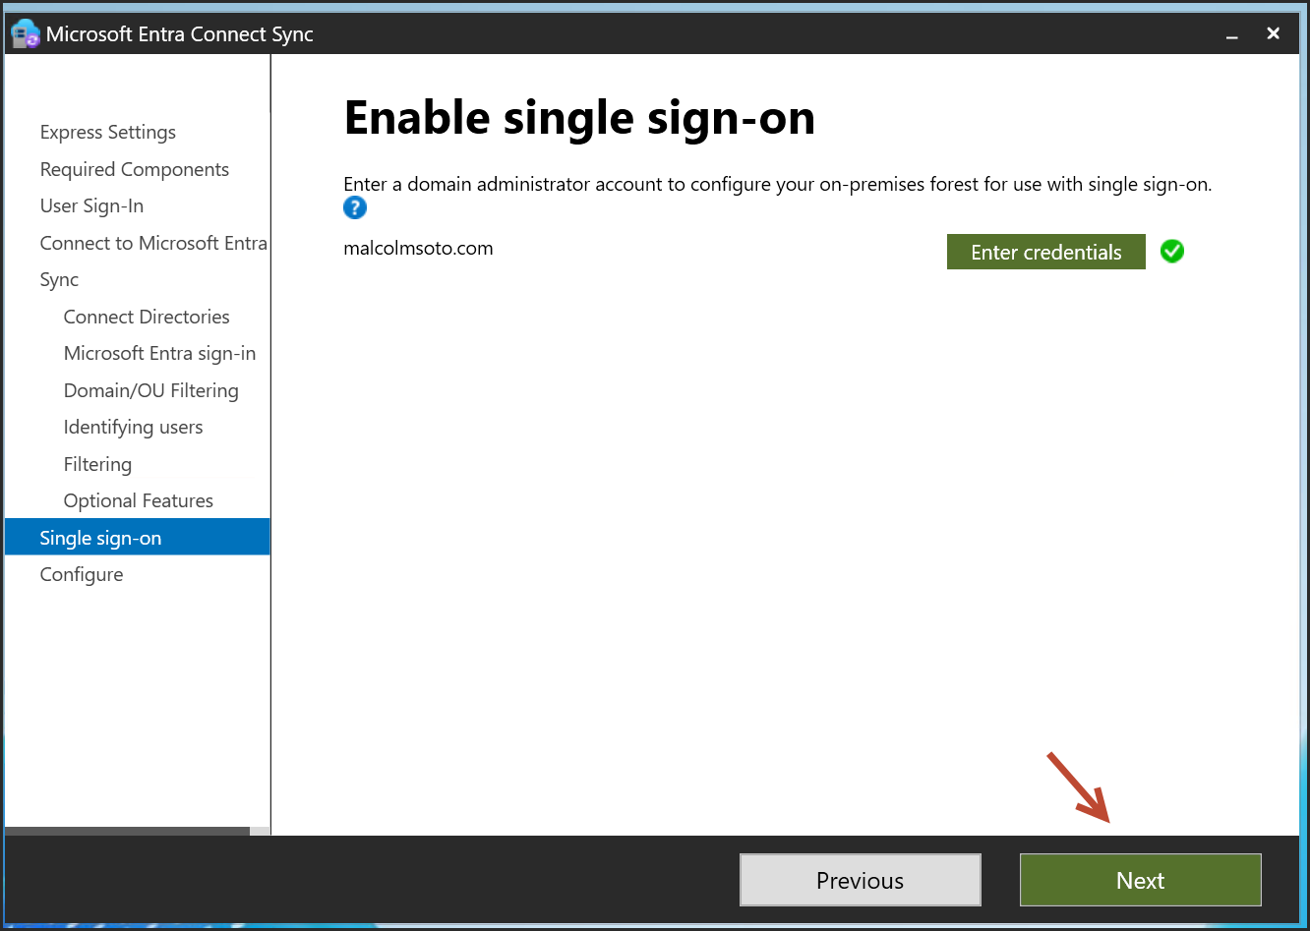

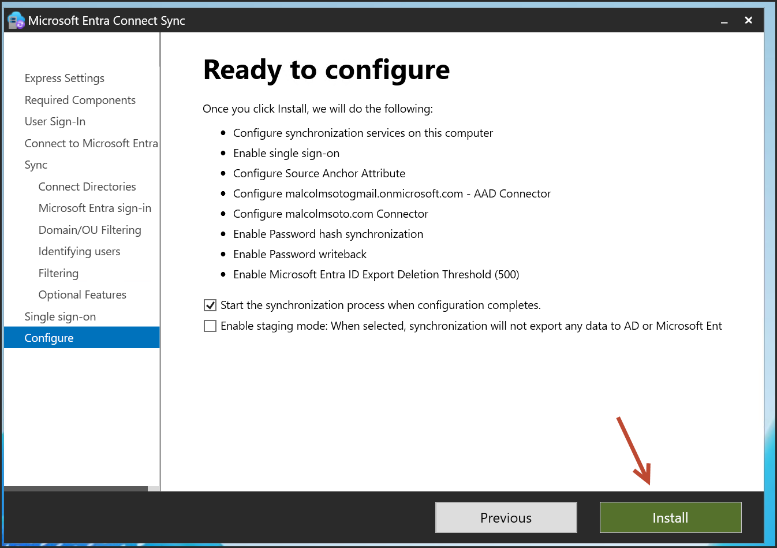

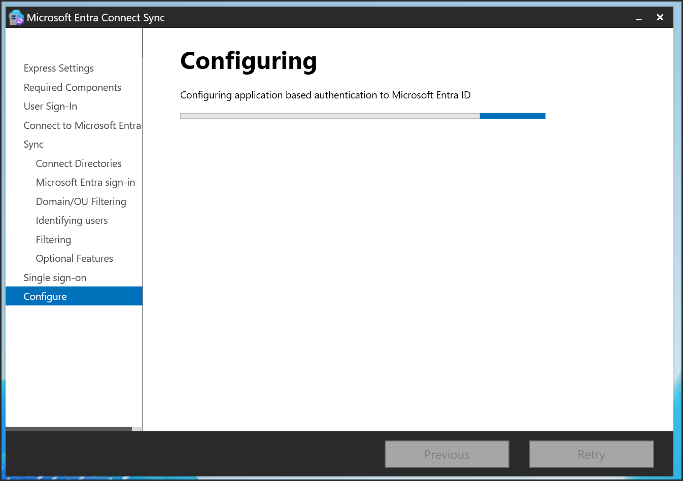

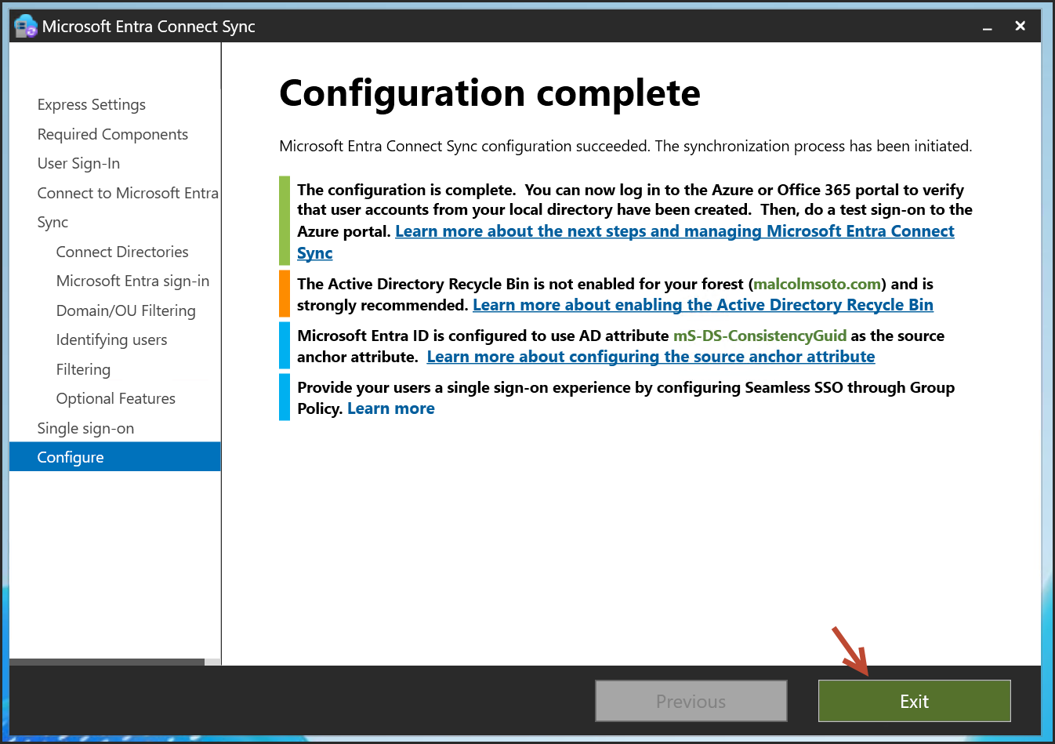

Let’s Enable Active Directory Recycle Bin

-Adds protection against accidental deletions

-Can be done via PowerShell:

Enable-ADOptionalFeature -Identity 'Recycle Bin Feature' -Scope ForestOrConfigurationSet -Target 'malcolmsoto.com'

Setup a Group Policy to Enable Seamless SSO

Open gpmc.ms

Create a policy and link it to the OU

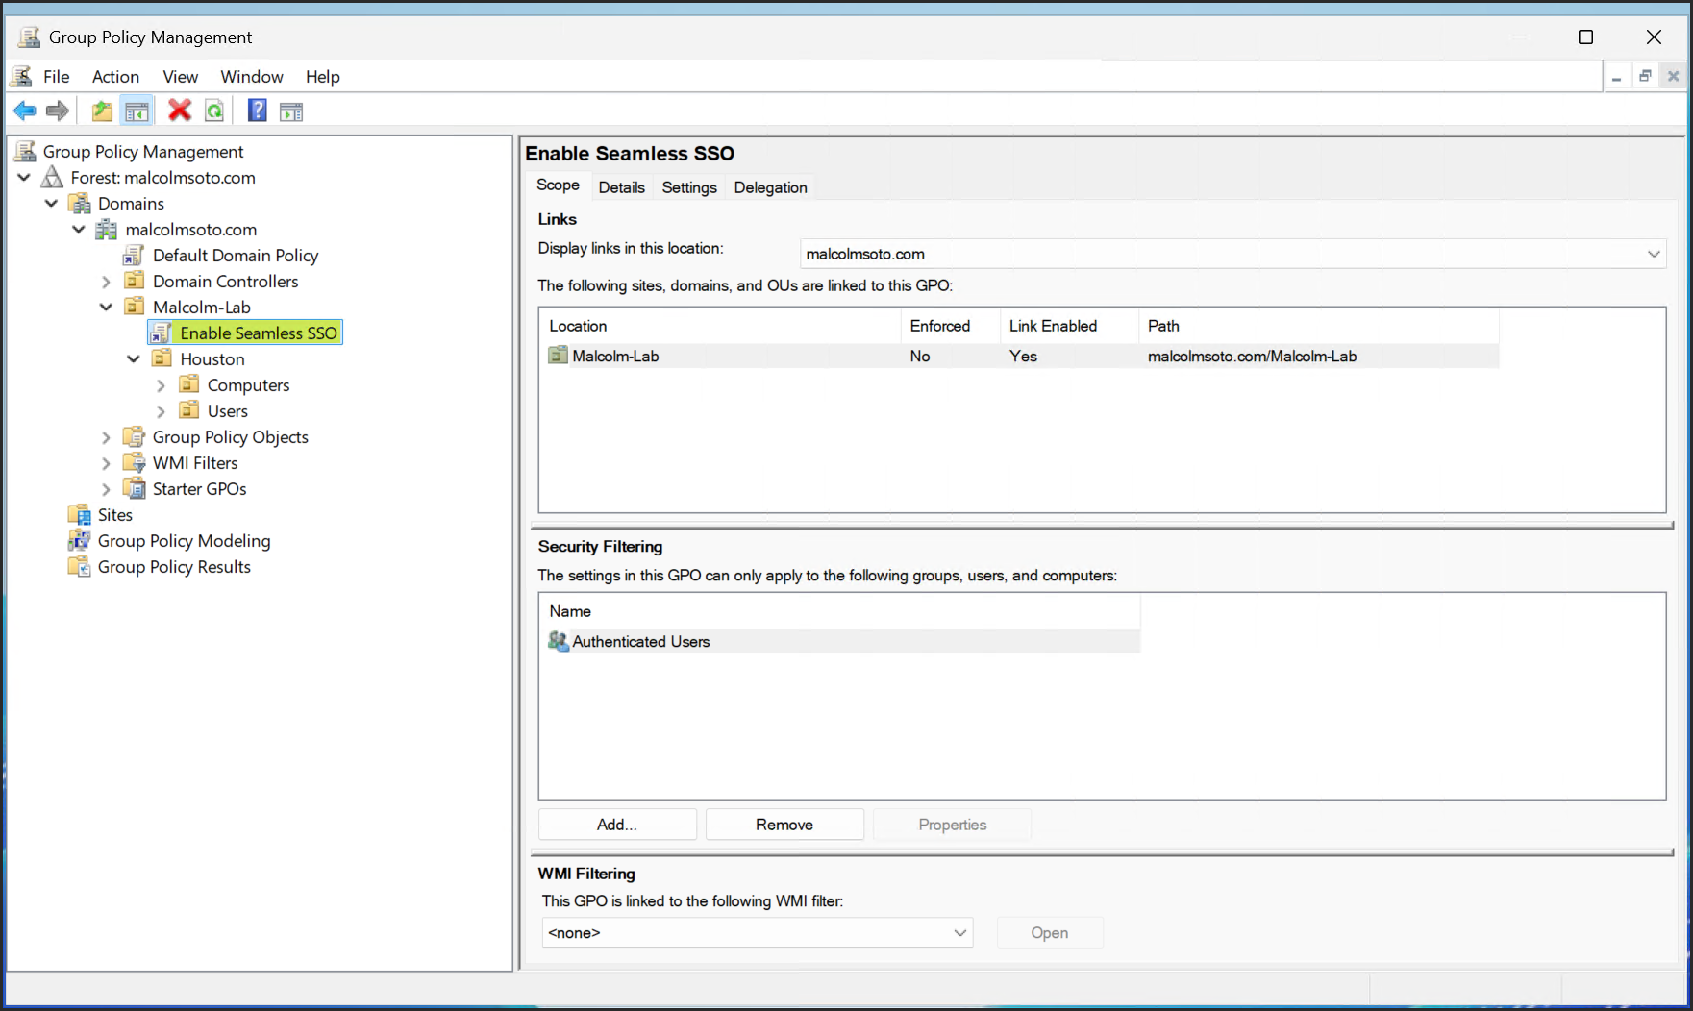

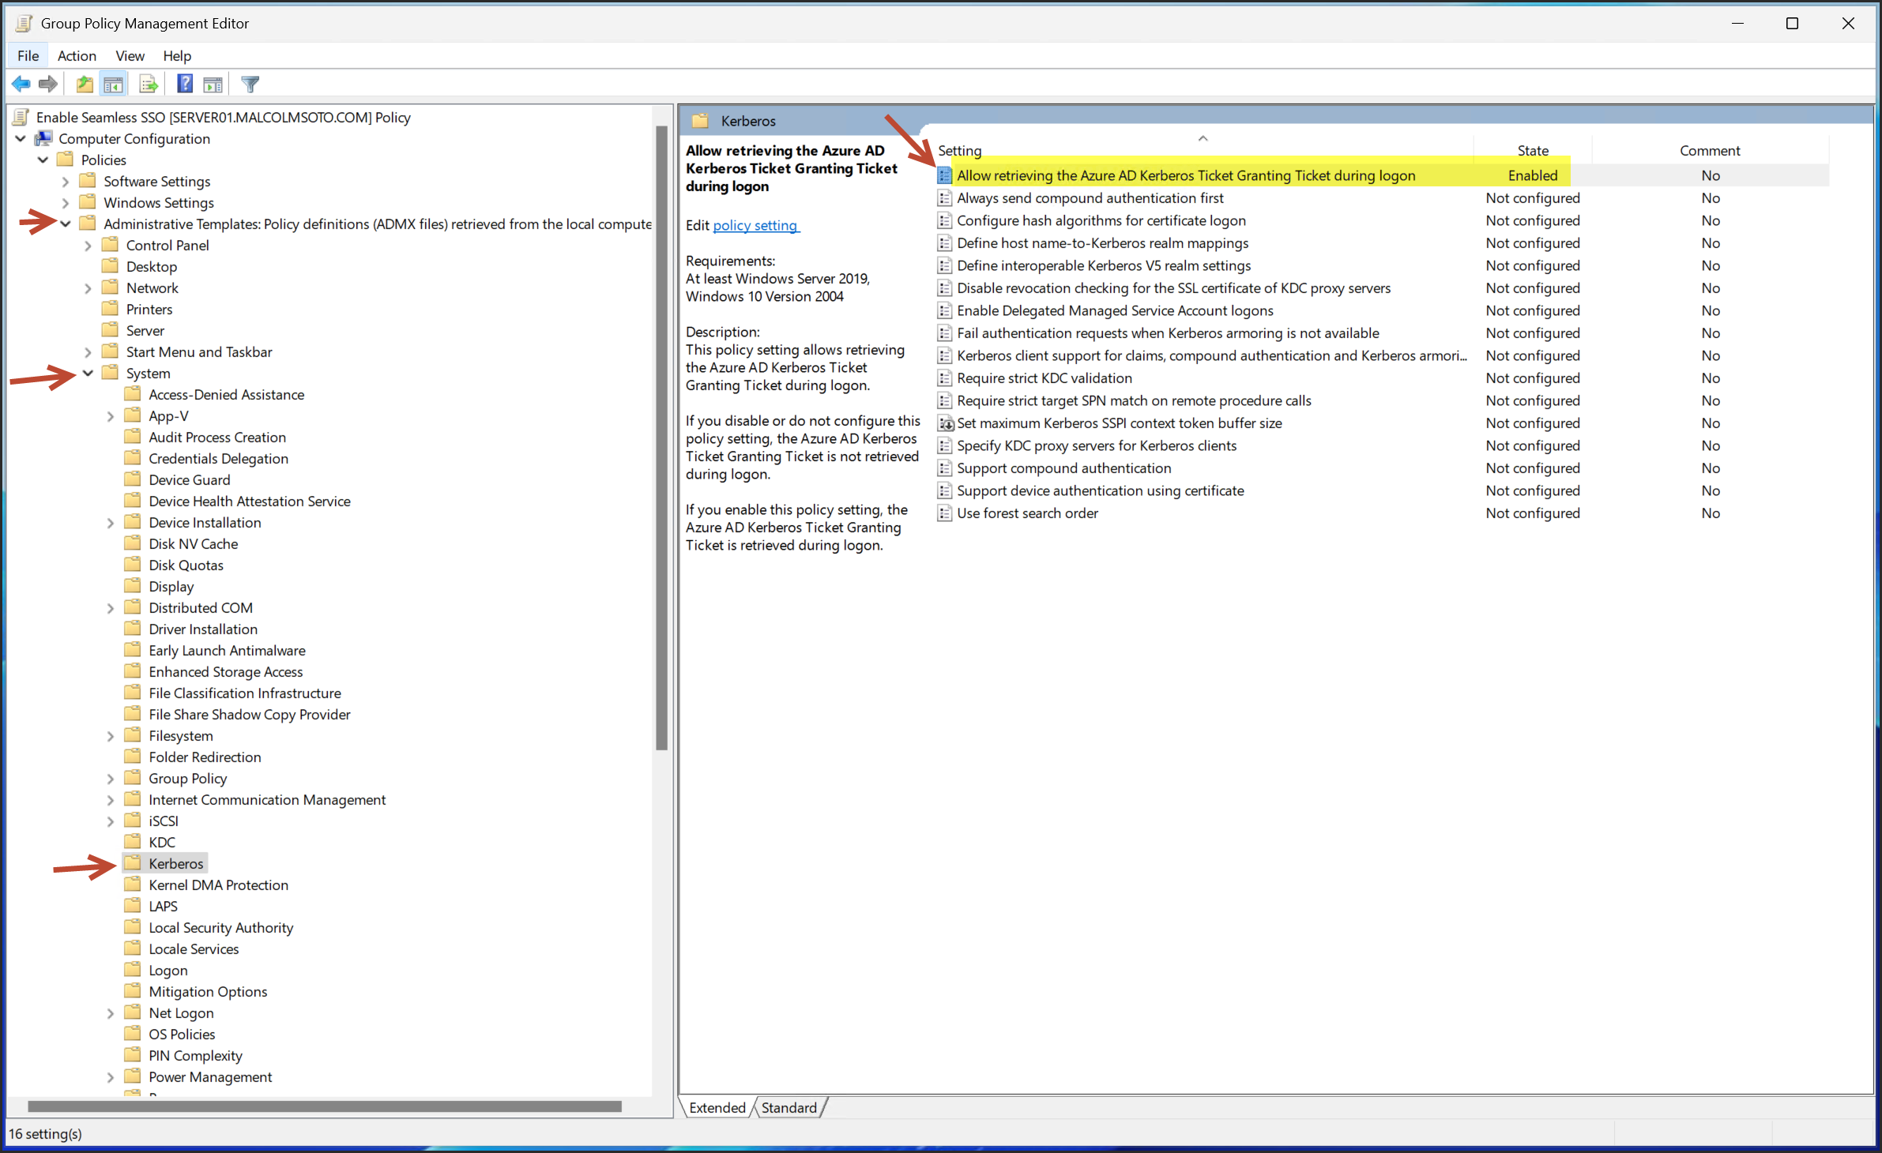

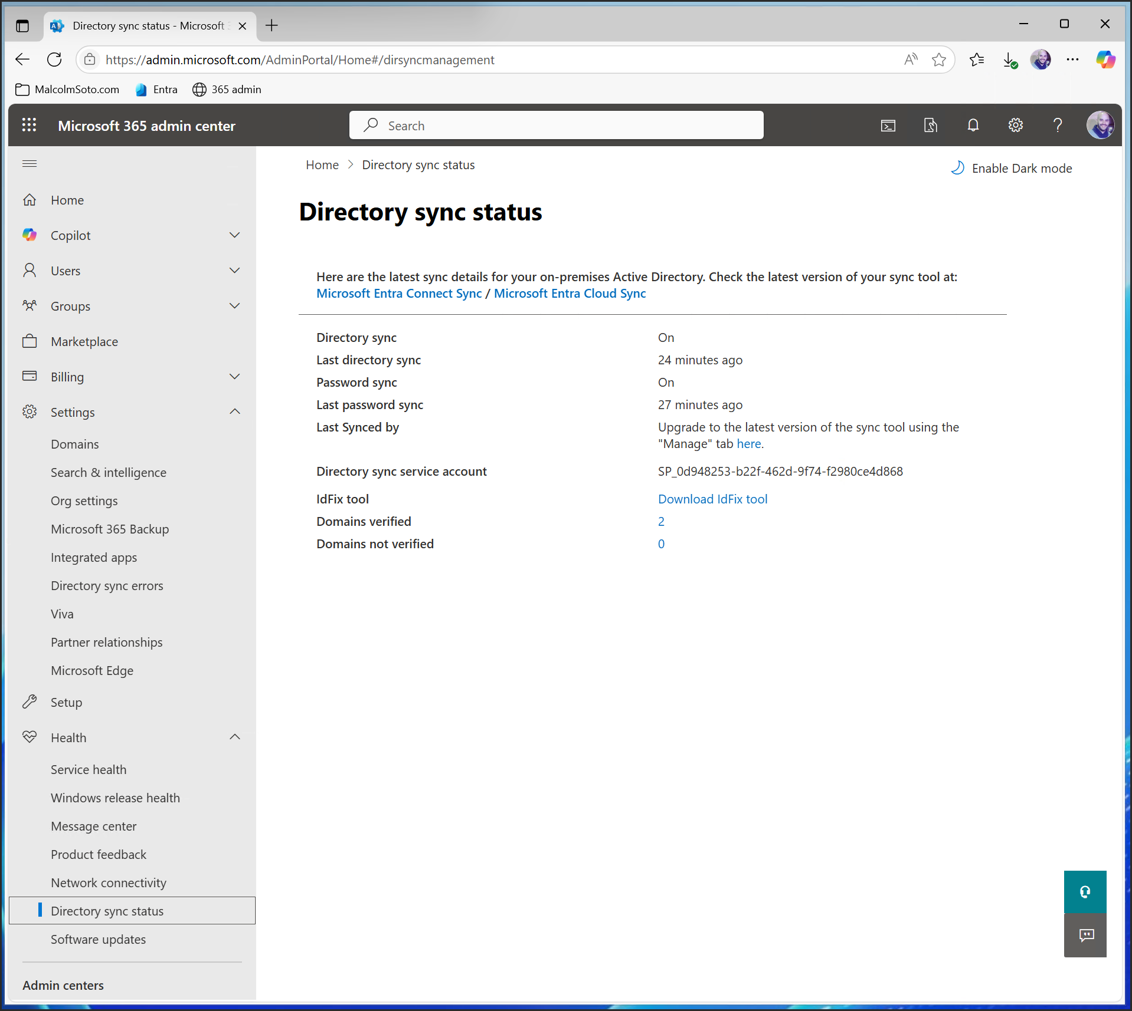

Go to https://admin.microsoft.com/  
Health > Directory sync status>  
Here you can check the status